LIBRARY MANAGEMENT
Objective
To understand and implement the core Object-Oriented Programming (OOP) concepts in Java.Concepts Covered
- Classes and Objects
- Constructors
- Encapsulation
- Inheritance
- Method Overloading
- Method Overriding
- Polymorphism
- Abstraction
- Interfaces
Task Description
Develop a "Library Management System" to demonstrate Object-Oriented Programming concepts.
Part A: Classes and Objects
Create a class named Book containing:
- Book ID
- Book Name
- Author
- Price
Create objects and display their details.
Part B: Constructors and Encapsulation
- Create both default and parameterized constructors.
- Declare data members as private.
- Access them using Getter and Setter methods.
Part C: Inheritance
Create the following classes:
- Person
- Student (inherits Person)
- Faculty (inherits Person)
Display the inherited properties using objects.
Part D: Polymorphism
Implement:
- Method Overloading for calculating the area of different shapes.
- Method Overriding by creating a Vehicle class and overriding the display() method in Car and Bike classes.
Part E: Abstraction and Interfaces
- Create an abstract class Shape containing an abstract method draw().
- Implement the draw() method in Circle and Rectangle classes.
- Create an interface Printable and implement it in a class named Report.
Algorithm
• Start the program.
• Create a Book object and assign book details directly to its data members.
• Display the book details.
• Create a Book1 object using the default constructor.
• Set the book details using setter methods and display them using getter methods.
• Create another Book1 object using the parameterized constructor and display its details.
• Create Student and Faculty objects.
• Display their details using inheritance from the Person class.
• Create an Area object and calculate the area of:
- Circle
- Rectangle
- Triangle
• Create Car and Bike objects using the Vehicle reference and display their details using method overriding.
• Create Circle and Rectangle objects using the Shape reference and call the draw() method using abstraction.
• Create a Report object using the Printable interface and call the print() method.
• Stop the program.
UMLl diagram
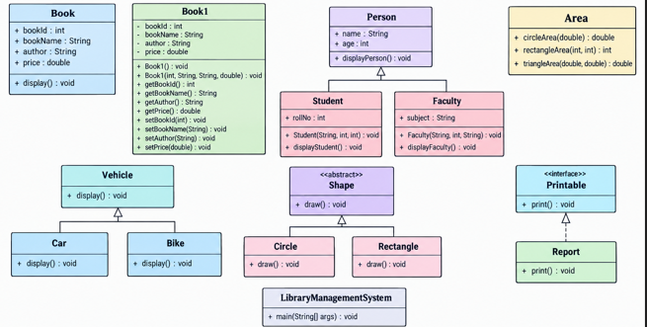

Code
package observation;
class Book {
int bookId;
String bookName;
String author;
double price;
void display() {
System.out.println("Book ID : " + bookId);
System.out.println("Book Name : " + bookName);
System.out.println("Author : " + author);
System.out.println("Price : " + price);
}
}

class Book1 {
// Private data members (Encapsulation)
private int bookId;
private String bookName;
private String author;
private double price;
// Default Constructor
public Book1() {
bookId = 0;
bookName = "Unknown";
author = "Unknown";
price = 0.0;
}
// Parameterized Constructor
public Book1(int bookId, String bookName, String author, double price) {
this.bookId = bookId;
this.bookName = bookName;
this.author = author;
this.price = price;
}
// Getter Methods
public int getBookId() {
return bookId;
}
public String getBookName() {
return bookName;
}
public String getAuthor() {
return author;
}
public double getPrice() {
return price;
}
// Setter Methods
public void setBookId(int bookId) {
this.bookId = bookId;
}
public void setBookName(String bookName) {
this.bookName = bookName;
}
public void setAuthor(String author) {
this.author = author;
}
public void setPrice(double price) {
this.price = price;
}
}

class Person {
String name;
int age;
Person(String name, int age) {
this.name = name;
this.age = age;
}
void displayPerson() {
System.out.println("Name : " + name);
System.out.println("Age : " + age);
}
}
class Student extends Person {
int rollNo;
Student(String name, int age, int rollNo) {
super(name, age);
this.rollNo = rollNo;
}
void displayStudent() {
displayPerson();
System.out.println("Roll No : " + rollNo);
}
}
class Faculty extends Person {
String subject;
Faculty(String name, int age, String subject) {
super(name, age);
this.subject = subject;
}
void displayFaculty() {
displayPerson();
System.out.println("Subject : " + subject);
}
}

class Area {
double circleArea(double radius) {
return 3.14 * radius * radius;
}
int rectangleArea(int length, int breadth) {
return length * breadth;
}
double triangleArea(double base, double height) {
return 0.5 * base * height;
}
}
class Vehicle {
void display() {
System.out.println("This is a Vehicle.");
}
}
class Car extends Vehicle {
@Override
void display() {
System.out.println("This is a Car.");
}
}
class Bike extends Vehicle {
@Override
void display() {
System.out.println("This is a Bike.");
}
}

abstract class Shape {
abstract void draw();
}
class Circle extends Shape {
@Override
void draw() {
System.out.println("Drawing Circle");
}
}
class Rectangle extends Shape {
@Override
void draw() {
System.out.println("Drawing Rectangle");
}
}
interface Printable {
void print();
}
class Report implements Printable {
@Override
public void print() {
System.out.println("Printing Report...");
}
}

public class LibraryManagementSystem {
public static void main(String[] args) {
Book b = new Book();
b.bookId = 101;
b.bookName = "Java Programming";
b.author = "James Gosling";
b.price = 499.99;
b.display();

Book1 b1 = new Book1();
b1.setBookId(101);
b1.setBookName("Java Programming");
b1.setAuthor("James Gosling");
b1.setPrice(499.99);
System.out.println("Book ID : " + b1.getBookId());
System.out.println("Book Name : " + b1.getBookName());
System.out.println("Author : " + b1.getAuthor());
System.out.println("Price : " + b1.getPrice());
Book1 b2 = new Book1(102, "Python Basics", "Guido van Rossum", 399.99);
System.out.println("\nBook ID : " + b2.getBookId());
System.out.println("Book Name : " + b2.getBookName());
System.out.println("Author : " + b2.getAuthor());
System.out.println("Price : " + b2.getPrice());

Student s = new Student("Rohan", 20, 101);
Faculty f = new Faculty("Dr. Kumar", 45, "Computer Science");
System.out.println("Student Details");
s.displayStudent();
System.out.println("Faculty Details");
f.displayFaculty();

Area area = new Area();
System.out.println("Area of Circle : " + area.circleArea(5.0));
System.out.println("Area of Rectangle : " + area.rectangleArea(10, 8));
System.out.println("Area of Triangle : " + area.triangleArea(12.0, 6.0));
Vehicle v;
v = new Car();
v.display();
v = new Bike();
v.display();

Shape circle = new Circle();
Shape rectangle = new Rectangle();
circle.draw();
rectangle.draw();
Printable report = new Report();
report.print();
}
}
Output
